# Integrated Retail Analytics for Store Optimization and Demand Forecasting

-Aniruddha Banerjee

### **Objective:**

To utilize machine learning and data analysis techniques to optimize store performance, forecast demand, and enhance customer experience through segmentation and personalized marketing strategies.

### **Project Components:**

**Anomaly Detection in Sales Data:**

**Point Anomalies: Individual Outliers**

These are isolated data points that stand out due to their extreme values or unique characteristics. For example, a sudden surge in website traffic or an unusually high-priced item in an online store can be considered point anomalies.

**Contextual Anomalies: Context-Dependent Deviations**

Contextual anomalies are data points that are considered anomalies only within a specific context or condition. One instance to consider is the occurrence of summer heatwaves in the United States. A notable observation reveals a significant surge in the year 1930, marking an extraordinary occurrence within the country known as the Dust Bowl. This term was coined due to a prolonged period of dust storms wreaking havoc in the south-central region of the United States.

**Collective Anomalies: Pattern Deviations**

Collective anomalies involve a group of data points or patterns of behavior that deviate from the expected norm. Detecting a recurring pattern of failed login attempts on a website could indicate a security breach and is an example of a collective anomaly.

**Understanding Anomalies in Retail Data**

Anomalies in retail data refer to unexpected and irregular patterns in customer behavior or transaction data that deviate significantly from the norm. These anomalies can take various forms:

* **Unusual Purchase Patterns 🛍️📈:** Anomalies may include sudden and significant spikes in purchase orders, whether in terms of quantity or transaction amount, that do not align with historical buying behavior.
* **Outliers in Customer Behavior 🧑🏻‍💼📉:** Some customers may exhibit behaviors that deviate significantly from the norm. For example, a customer may abruptly change their buying preferences or frequency of purchases.
* **Seasonal or Event-Driven Spikes 🎉🎁:** Anomalies can occur during special events, holidays, or sales promotions when there is a sudden and substantial increase in sales or website traffic.
* **Fraudulent Activities 🕵️‍♂️💳:**Retail data may contain anomalies related to fraudulent activities, such as unauthorized transactions, stolen credit card usage, or account takeovers.

### **Methods for Detecting Anomalies in Retail Data**

Detecting anomalies in retail data is a multifaceted task that relies on a combination of statistical methods, machine learning algorithms, and domain expertise. Each of these methods offers a unique approach to identifying irregularities or unusual patterns in data, and they play a critical role in improving decision-making, security, and operational efficiency in the retail sector.

**Descriptive Statistics**:

Descriptive statistics are among the foundational methods for anomaly detection in retail. Techniques like mean, median, and standard deviation can be used to calculate summary statistics, which help identify point anomalies.

**Time-Series Analysis :**

Time-series analysis is particularly relevant in the retail industry, where data often involves a temporal component. Methods like Exponential Smoothing or Seasonal Decomposition of Time Series (STL) allow retailers to analyze historical sales data and identify anomalies in patterns or trends over time.

**Machine Learning :**

Machine learning has emerged as a powerful tool for anomaly detection in various retail data streams. Supervised and unsupervised techniques like Isolation Forests, One-Class SVMs, or Autoencoders can be trained to recognize anomalies in transaction data, customer behavior, or inventory levels.

**Rule-Based Systems :**

Rule-based systems offer a straightforward way for retailers to define rules or thresholds that trigger alerts when certain conditions are met. These rules can be tailored to specific business needs. For example, setting a rule to flag any transaction above a certain monetary value as suspicious or triggering an alert when there is a sudden increase in returns. Rule-based systems provide a proactive approach to anomaly detection and enable rapid response to potential issues.

**Mitigation Strategies**

There are a number of strategies that can be used to mitigate the impact of anomalies without removing the data points. These strategies include:

**Data cleaning:** This involves identifying and correcting errors in the data. This can be done manually or using automated tools.

**Data normalization:** This involves transforming the data so that it is distributed normally. This can help to identify anomalies more easily.

**Data imputation:** This involves filling in missing data points. This can be done using statistical methods or machine learning algorithms.

**Anomalies in Weekly Sales**

**Rationale**

Weekly sales data often exhibit regular patterns and fluctuations due to various factors such as seasonality, promotions, and consumer behavior. However, anomalies in this data can provide valuable insights into exceptional events or irregularities that deviate significantly from the norm. By identifying anomalies, businesses can uncover potential issues, opportunities, or areas for improvement in their sales processes.

Implement a range of techniques to detect anomalies in the dataset. This includes statistical methods like Descriptive Statistics, Z-score and IQR (Interquartile Range) as well asadvanced machine learning algorithms like Isolation Forest and One-Class SVM.

**Methodology**

**Descriptive Statistics:**

We begin by analyzing the distribution of weekly sales data using descriptive statistics. Descriptive statistics provide a summary of key characteristics of the data, including measures of central tendency (mean, median), dispersion (standard deviation), and shape (skewness, kurtosis).

**Standard Deviation Threshold**:

To identify anomalies, we utilize the standard deviation as a measure of dispersion. The standard deviation quantifies the average distance of data points from the mean. By setting a threshold based on a multiple of the standard deviation, we can identify data points that fall significantly outside the expected range.

**Threshold Calculation**:

In our approach, we set the threshold for anomaly detection to three times the standard deviation. This choice of threshold is based on the empirical rule, which states that approximately 99.7% of data points in a normally distributed dataset fall within three standard deviations of the mean. Therefore, data points beyond this threshold are considered potential anomalies.

**Identification of Anomalies**:

After setting the threshold, we identify data points in the weekly sales dataset that exceed the threshold value. These data points represent instances where the observed sales deviate significantly from the expected values based on historical trends.

**Implications**

**Early Detection of Issues**: By flagging anomalies in weekly sales data, businesses can proactively identify issues such as inventory discrepancies, pricing errors, or operational challenges.

**Opportunity Identification**: Anomalies in sales data may also indicate opportunities for revenue growth or optimization. For example, sudden spikes in sales may reveal the effectiveness of marketing campaigns or customer engagement initiatives.

**Data Quality Assurance**: Anomaly detection serves as a quality assurance mechanism for sales data. By validating the consistency and integrity of the data, businesses can ensure the reliability of their analytical insights and decision-making processes.

**Importance of Post-Detection Anomaly Handling**

Handling anomalies is crucial for several reasons:

**Security:** Anomalies may indicate security breaches or attacks on a system.

**System Reliability:** Anomalies can affect system performance, stability, and reliability.

**Data Quality:** Addressing anomalies helps maintain data quality and accuracy.

**Compliance:** Some industries have regulatory requirements for handling anomalies

**Key Goals of Anomaly Handling Strategies**

Effective anomaly handling strategies aim to achieve the following goals:

**Minimize False Positives:** Avoid unnecessary alarms or responses triggered by benign deviations.

**Maximize True Positives:** Detect and respond to real anomalies accurately and promptly.

**Reduce Response Time:** Minimize the time between anomaly detection and action, especially in critical scenarios.

**Optimize Resource Utilization:** Allocate resources efficiently to investigate and mitigate anomalies.

**Continuous Improvement:** Learn from past anomalies to enhance future anomaly detection and handling.

**Removing Anomalous Data**

When anomalous data is detected, one option is to remove it from the dataset. This can be done in a number of ways-

**Removing Anomalous Data Using Interquartile Range (IQR):**

The Interquartile Range (IQR) is a robust measure of spread in a dataset that is less sensitive to outliers compared to measures such as the standard deviation. It is defined as the difference between the third quartile (Q3) and the first quartile (Q1). The IQR provides a measure of the spread of the middle 50% of the data.

**Benefits of Using IQR for Outlier Removal:**

**Robustness**: The IQR method is robust to extreme values and outliers, making it suitable for datasets with skewed distributions or anomalous observations.

**Conclusion**

In conclusion, leveraging descriptive statistics and setting a threshold based on three times the standard deviation provides a robust approach to identifying anomalies in weekly sales data.

After anomaly detection, we have handled the anomaly using IQR technique on weekly sales features.

This methodology enables businesses to uncover actionable insights, mitigate risks, and enhance the overall

**Time-Based Anomaly Detection:**

**Objective:**

Analyze sales trends over time.

Detect seasonal variations and holiday effects on sales.

Use time-series analysis for understanding store and department performance over time.

Detects anomalies in time series Sales data using specialized methods.

💡 Approach:

📊 Create Rolling Statistics: Calculate rolling averages, moving sums, and standard deviations to track data variations over time.

🔄 Apply Exponential Smoothing: Use exponential moving averages (EMA) and anomaly detection techniques to highlight unusual patterns in time series data.

🚨 Highlight Anomalies: Set thresholds and visual cues to identify significant deviations from smoothed values, aiding in anomaly detection and trend analysis.

**Time Based Anomaly**

Time-based anomaly detection refers to the process of identifying unusual patterns or deviations from expected behavior in time-series data. This technique is commonly used in various fields such as cybersecurity, finance, manufacturing, and healthcare to detect abnormal events or anomalies that may indicate potential problems or threats.

Some common techniques used in time-based anomaly detection include:

* Statistical Methods: Such as mean, median, standard deviation, z-score, or percentiles to detect deviations from the expected statistical properties of the data.
* Machine Learning Algorithms: Including supervised learning methods like Support Vector Machines (SVM), Random Forests, or neural networks, as well as unsupervised learning techniques like k-means clustering, isolation forests, or autoencoders.
* Time-Series Analysis: Techniques like seasonality decomposition, trend analysis, autocorrelation, or spectral analysis to identify abnormal patterns in the time-series data.

Overall, time-based anomaly detection plays a crucial role in monitoring and maintaining the integrity, security, and reliability of systems and processes by identifying and mitigating potential threats or abnormalities in time-series data.

**Challenges in detecting anomalies in time-based data:**

Temporal shifts refer to changes or variations in patterns, trends, or distributions over time in time-based data. These shifts can manifest in various ways and can complicate anomaly detection, as they often make it challenging to distinguish between genuine anomalies and shifts that are part of the normal evolution of the data. Here's a more detailed look at temporal shifts in time-based data, how they complicate anomaly detection, and strategies to account for them:

**Definition and Examples of Temporal Shifts:**

* **Seasonal Shifts:**These are regular patterns that occur over specific time intervals, such as daily, weekly, or annually. For example, retail sales may see a surge in December due to the holiday season.
* **Trend Shifts:** A change in the overall direction of data points over time. For instance, a tech company's stock price might have a long-term upward trend, but this trend could shift to a downward direction due to market changes.
* **Sudden Events:** Unpredictable events like natural disasters, political upheavals, or unexpected product failures can introduce sudden shifts in time-based data. For example, a sudden drop in website traffic due to a server outage.
* **Gradual Changes:** These shifts occur slowly over time and may be caused by factors like changing consumer preferences, technological advancements, or demographic shifts. An example is the gradual decline in the use of landline phones.

**How Temporal Shifts Complicate Anomaly Detection:**

Temporal shifts complicate anomaly detection because they can lead to variations in the data that are not necessarily anomalous but are due to the underlying dynamics. Anomaly detection models trained on historical data may struggle to adapt to these shifts, resulting in increased false positives or false negatives. For example, if you have a model trained on retail sales data from non-holiday periods, it may flag higher sales during holiday seasons as anomalies if it doesn't account for temporal shifts.

**Strategies to Account for Temporal Shifts in Anomaly Detection:**

* **Rolling Statistics:** Calculate rolling statistics (e.g., moving averages or moving standard deviations) over a fixed window of historical data. Use these statistics as a reference to detect anomalies in new data. This approach can help capture gradual shifts in data.
* **Seasonal Decomposition:** Decompose time series data into its seasonal, trend, and residual components using techniques like seasonal decomposition of time series (STL). Anomalies can then be detected in the residual component, which should be free from seasonality and trend.
* **Prophet Model (Facebook Prophet):** Prophet is a forecasting model that handles time series data with seasonality and trend components. It can be used for anomaly detection by comparing predicted values with observed values. Significant deviations can be flagged as anomalies.
* **Machine Learning Models:** Train machine learning models, such as Random Forest, LSTM (Long Short-Term Memory), or ARIMA (AutoRegressive Integrated Moving Average), with features that capture temporal information (e.g., lag values, seasonal indicators). These models can learn to adapt to temporal shifts.

We have used Rolling statistics to detect the anomalies

Rolling statistics, also known as rolling or moving averages, are statistical measures calculated over a rolling window or moving time frame within a time-series dataset. Instead of calculating the statistic for the entire dataset at once, rolling statistics are computed iteratively for each subset of the data defined by the rolling window.

**Exponential Weighted Moving Average (EWMA)**

Exponential Weighted Moving Average (EWMA) is a statistical technique used for smoothing time-series data by assigning exponentially decreasing weights to observations over time. Unlike simple moving averages, where all observations in the window are weighted equally, EWMA gives more weight to recent data points while gradually decreasing the influence of older observations.

Key features and advantages of EWMA include:

1. Adaptive Smoothing: EWMA adapts to changes in the underlying data pattern by giving more weight to recent observations. This makes it more responsive to short-term fluctuations and trends compared to simple moving averages.
2. Efficient Computation: Since EWMA only requires the previous moving average and the current observation, it can be efficiently computed in real-time or on streaming data without storing the entire history of observations.
3. Flexibility: The smoothing factor
4. 𝛼
5. *α* allows users to control the degree of smoothing and the trade-off between responsiveness and stability. Higher values of 𝛼
6. *α* result in smoother curves but may lag behind abrupt changes in the data.
7. Noise Reduction: EWMA helps reduce the impact of random noise or outliers in the time series, resulting in a smoother and more interpretable signal.
8. Applications of EWMA include:
9. Financial Analysis: EWMA is commonly used in finance for risk management, portfolio optimization, and technical analysis of stock prices and financial indicators.
10. Demand Forecasting: EWMA can be applied to smooth historical demand data and generate forecasts for future demand, helping businesses optimize inventory levels and production schedules.
11. Quality Control: EWMA is used in manufacturing and process industries for detecting deviations from target values in quality control metrics such as temperature, pressure, or chemical concentrations.
12. Overall, Exponential Weighted Moving Average is a versatile and widely used technique for smoothing time-series data, capturing underlying trends, and making data-driven decisions in various domains.

**Observations:**

The exponential Weighted moving average (EWMA) of Amazon sales data has been nearly steady with a few unexpected spikes over time, indicating that overall sales are trending constant with a few seasonal fluctuations.

There are a few anomalies in the sales data, as indicated by the green dots on the graph. These anomalies could be caused by a variety of factors, such as special holidays, seasonal fluctuations, or unexpected events.

#### **Conclusion:**

In this project, we employed time-based anomaly detection techniques to analyze sales trends and detect irregular patterns in time-series data. Our approach involved the creation of rolling statistics and the application of exponential smoothing methods to identify anomalies and understand store and department performance over time.

# **Customer Segmentation Analysis:**

**Objective:**

Segment stores or departments based on sales patterns, markdowns, and regional features.

Analyze segment-specific trends and characteristics.

Evaluate the effectiveness of the customer segmentation.

Use metrics to assess the quality of segments in terms of homogeneity and separation.

Develop personalized marketing strategies based on the store and department segments.

Propose inventory management strategies tailored to store and department needs.

**Customer segmentation**

Customer segmentation is a critical marketing strategy that involves dividing a customer base into distinct groups based on specific criteria or characteristics.

This practice offers a plethora of benefits for businesses. First and foremost, it enhances customer engagement by allowing companies to tailor their marketing campaigns, messages, and promotions to match the unique needs and preferences of each segment, ultimately boosting customer loyalty and retention.

Moreover, it optimizes product development by providing valuable insights into what different groups of customers are seeking, helping to refine existing offerings or create new ones that cater to these specific needs.

Furthermore, it promotes cost efficiency by focusing resources on the segments most likely to yield high returns, reducing wasted marketing spend.

Personalization becomes possible, strengthening customer relationships, while competitive advantages arise from better understanding and serving segments more effectively than competitors.

Additionally, customer segmentation allows businesses to develop feedback loops, refine strategies, and adapt to evolving customer preferences, enhancing long-term growth prospects.

Cross-selling and upselling opportunities emerge, increasing revenue per customer, while risk mitigation is achieved by diversifying the customer base.

This strategic approach not only fosters sustainable growth but also identifies potential markets for expansion, making it a cornerstone of modern marketing and business success.

**Importance of Customer Segmentation?**

* **Enhanced Customer Retention:** Customer segmentation not only helps in acquiring new customers but also plays a crucial role in retaining existing ones. By tailoring products, services, and communication to the preferences and needs of each segment, businesses can reduce churn rates and build stronger, longer-lasting customer relationships.
* **Refined Pricing Strategies:** Segmentation can inform pricing strategies by identifying which customer segments are price-sensitive and which are willing to pay premium prices for added value. This allows businesses to maximize revenue and profitability.
* **Tailored Customer Support:** Different customer segments may have varying support needs and communication preferences. With segmentation, businesses can provide personalized customer support experiences, leading to higher satisfaction and reduced support costs.
* **Data-Driven Decision Making:** Customer segmentation relies on data analysis, fostering a data-driven culture within an organization. This approach helps businesses make informed decisions across various departments, from marketing and product development to sales and customer service.
* **International Expansion**: For businesses looking to expand into international markets, customer segmentation can help identify cultural, linguistic, and regional differences among customer groups. This knowledge is invaluable for successful global expansion.
* **Effective Inventory Management:** Segmentation can guide inventory management by predicting the demand for different products within each segment. This prevents overstocking or understocking issues and ensures that products are available when and where customers want them.

**Types of Customer Segmentation**

* **Behavioral Segmentation**: Groups customers based on their interactions with the brand, such as website visits, product views, or purchase history.
* **RFM Analysis**: Analyzes Recency, Frequency, and Monetary value of customer transactions to identify high-value segments.
* **Predictive Segmentation**: Uses machine learning algorithms to predict customer behavior and segment customers based on these predictions.
* **Cohort Analysis**: Groups customers who share similar characteristics or experiences, often based on sign-up dates or initial purchase periods.

**Customer Segmentation Algorithms**

* **K-Means Clustering**:
  + Divides customers into K clusters based on their similarity in terms of chosen features (e.g., purchase frequency and amount).
* **Hierarchical Clustering**:
  + Forms a hierarchical tree of clusters, allowing for both broad and fine-grained segmentation.
* **DBSCAN (Density-Based Spatial Clustering of Applications with Noise)**:
  + Identifies clusters based on data density, useful for irregularly shaped clusters.

**Applications and Benefits**

* **Personalized Marketing**: Customer segmentation allows businesses to deliver highly personalized marketing content, messages, and promotions to different segments. This level of personalization increases the likelihood of capturing the attention and interest of each group, resulting in higher conversion rates and customer engagement.
* **Improved Customer Retention**: By identifying and addressing the unique needs and preferences of high-value customer segments, businesses can enhance customer retention. These segments often drive a significant portion of revenue, making it essential to focus on maintaining their loyalty and satisfaction.
* **Enhanced Product Development**: Customer segmentation provides valuable insights into specific customer preferences and pain points. This information can be leveraged to create products that cater to the unique needs of each segment, increasing the likelihood of product success in the market.
* **Reduced Customer Acquisition Costs**: Targeted marketing efforts, made possible through segmentation, can reduce customer acquisition costs. By focusing resources on the most promising customer segments, businesses can optimize their marketing budget and achieve a higher return on investment.
* **Market Expansion Strategies**: Customer segmentation not only helps in serving existing markets but also in identifying opportunities for market expansion. Businesses can use segmentation to analyze untapped markets, adapt their offerings, and enter new geographic regions or customer niches strategically.

I have used the K-Means Clustering algorithm for store and department segmentation.

K-Means Clustering is a popular unsupervised machine learning algorithm used for partitioning data into distinct groups, or clusters, based on similarity. In the context of store and department segmentation, K-Means Clustering offers a powerful approach to identifying meaningful patterns and structures within the data without the need for labeled training examples.

The process of using K-Means Clustering for store and department segmentation typically involves the following steps:

1. **Data Collection and Preprocessing:** The first step is to gather relevant data about stores and departments, including variables such as store size, average weekly sales, consumer price index, and other relevant metrics. The data may come from various sources such as sales records, customer demographics, and inventory data. Once collected, the data is preprocessed to handle missing values, scale numerical features, and encode categorical variables if necessary.
2. **Feature Selection:** After preprocessing the data, the next step is to select the features that will be used for clustering. These features should capture the characteristics that differentiate stores or departments from each other. Common features used for store and department segmentation include store size, sales performance, customer demographics, geographical location, and product assortment.
3. **Determining the Number of Clusters:** One of the key decisions in applying K-Means Clustering is determining the optimal number of clusters (K) to partition the data. This can be done using techniques such as the Elbow Method, Silhouette Score, or Gap Statistics. The goal is to find a value of K that maximizes the homogeneity within clusters while minimizing the heterogeneity between clusters. The optimal number of clusters based on Silhouette score was 4 and we have considered 4 as the optimal number of clusters in K-Means Algorithm.
4. **Applying K-Means Clustering:** With the number of clusters determined, the K-Means Clustering algorithm is applied to the preprocessed data. The algorithm iteratively assigns each data point to the nearest cluster centroid and updates the centroids based on the mean of the data points assigned to each cluster. This process continues until convergence, where the centroids no longer change significantly or a maximum number of iterations is reached.

**Interpreting Cluster Results:** Once the clustering process is complete, the resulting clusters are interpreted to understand the characteristics and behaviors of the stores or departments within each cluster. **Segmentation Quality Evaluation:**

Evaluate the effectiveness of the customer segmentation.

Use metrics to assess the quality of segments in terms of homogeneity and separation.

Segment quality evaluation is a crucial step in various data analysis and machine learning tasks, especially in areas like natural language processing (NLP), computer vision, and speech performance of models or algorithms in dividing data into meaningful segments or clusters. Here, we'll explore several essential metrics and techniques used for evaluating segment quality.

1. **Silhouette Score** 🏞️
   * The Silhouette Score measures how similar an object is to its own cluster compared to other clusters. It ranges from -1 to 1, where higher values indicate better segment quality.
2. **Davies-Bouldin Index** 🗻
   * This index quantifies the average similarity between each cluster and its most similar cluster. Lower values indicate better segmentation.
3. **Inertia (Within-Cluster Sum of Squares)** 🎯
   * Inertia measures the sum of squared distances from each data point to its nearest cluster center. Lower inertia implies better clustering.

In summary, segment quality evaluation is a multifaceted process that requires considering various metrics and techniques. The choice of metrics depends on the specific problem and data characteristics. Using a combination of these metrics can provide a comprehensive assessment of the quality of clustering or segmentation results.

In this project, in order to evaluate the store and department segments I have used a Silhouette score metric to find out the optimal number of clusters.

The highest Silhouette score was obtained with a cluster value of 4. Therefore, we have chosen 4 as the optimal cluster value based on the Silhouette score.

**Personalization with Segments**

* Develop personalized marketing strategies based on the store and department segments.
* Propose inventory management strategies tailored to store and department needs.

The learning objective of "Personalization with Customer Segments" is centered on the art and science of tailoring experiences, recommendations, and solutions to distinct groups of customers. In a dynamic business landscape, understanding customer segmentation and harnessing its potential is crucial. This objective delves into the fundamental concepts of customer segmentation, empowering learners to grasp the significance of segmenting audiences based on demographics, behaviors, and preferences. It guides individuals through the process of collecting and preparing data, identifying and labeling customer segments, and designing personalized strategies that cater to each group's unique needs. Moreover, it equips learners with the skills to build custom machine learning models, evaluate their performance within specific segments, and responsibly deploy them in real-world scenarios. By achieving this objective, learners will gain the expertise to drive engagement, conversion rates, and customer satisfaction through the power of personalized experiences, all while staying ethically mindful and attuned to business impact.

**Store Segmentation Analysis**

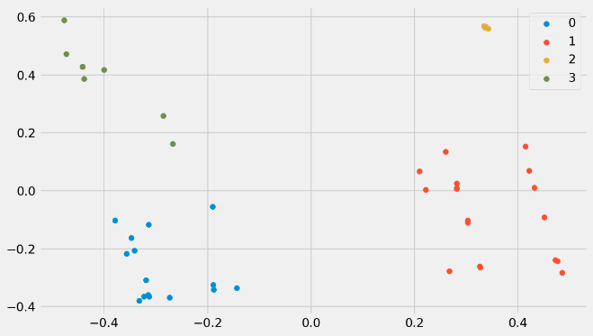

The number of stores per cluster are as follows:-

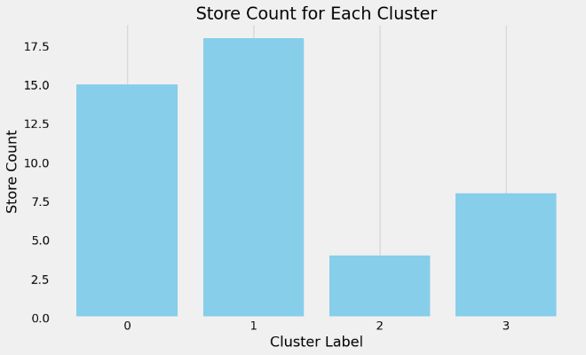

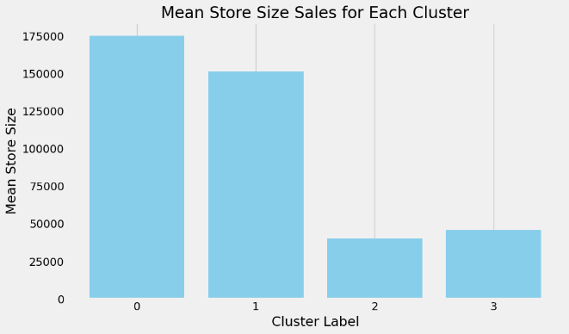

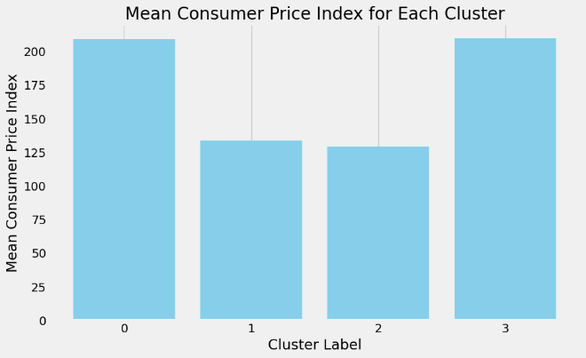

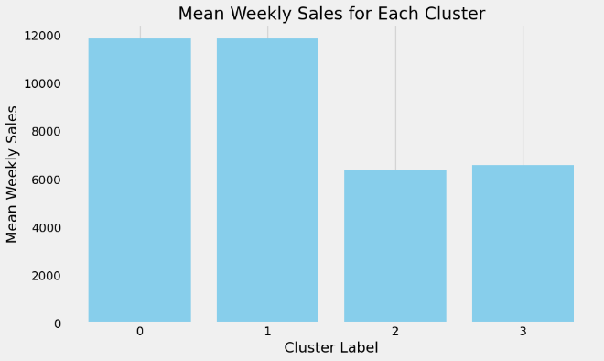

**Cluster 0: Premium Space Retailers & Sizeable Luxury Stores**

This cluster consists of stores known for their larger physical footprint and is distinguished by having the highest mean consumer price index among the clusters. The average weekly sales in Cluster 0 stores total 11848, with a total of 15 stores belonging to this group. This cluster can be defined as comprising stores with significant physical space and catering to consumers with higher-priced products.

**Cluster 1: Value-Oriented Stores**

This cluster represents stores with an average weekly sales totaling 11851, with 18 stores in total. It ranks as the second-largest cluster in terms of store sizes and is notable for having the lowest mean consumer price index. Described as comprising stores with medium physical space, it caters to consumers seeking lower-priced products while offering value-oriented shopping experiences.

**Cluster 2: Budget-Friendly Stores**

This cluster represents stores characterized by their lowest average weekly sales, totaling 6362. These stores are notable for their small physical footprint and have the lowest mean consumer price index among the clusters. With a total of 4 stores in this group, it can be defined as comprising stores catering to consumers seeking lower-priced products in compact retail spaces.

**Cluster 3: Compact Elegance Stores**

This cluster encompasses stores known for their smaller physical dimensions and stands out for having a higher mean consumer price index compared to other clusters. The average weekly sales in Cluster 3 stores total 6579, which is relatively lower, with a total of 8 stores belonging to this group.

**Personalized Marketing Strategies for Store Segments :**

**Cluster 0: Premium Space Retailers & Sizeable Luxury Stores**

Marketing campaigns should highlight the spaciousness and luxury ambiance of the stores.

Emphasize premium product lines and exclusive offerings to attract affluent customers.

Collaborate with high-end brands for co-marketing opportunities to reinforce the store's upscale image.

**Cluster 1: Value-Oriented Stores**

Focus marketing efforts on value-conscious consumers by highlighting competitive pricing and promotions.

Leverage social media platforms and targeted digital advertising to reach budget-conscious shoppers.

Offer loyalty programs and discounts to incentivize repeat purchases and foster customer loyalty.

**Cluster 2: Budget-Friendly Stores**

Promote budget-friendly product lines and emphasize affordability in marketing messaging.

Utilize cost-effective marketing channels such as email campaigns and local advertising.

Highlight deals, discounts, and clearance sales to attract price-sensitive customers.

**Cluster 3: Compact Elegance Stores**

Position the stores as boutique destinations offering curated selections of premium products.

Highlight the elegance and sophistication of the store ambiance in marketing materials.

Target niche market segments such as urban professionals or luxury enthusiasts through personalized outreach and experiential marketing events.

**Inventory Management Strategies for Store Segments:**

**Cluster 0: Premium Space Retailers & Sizeable Luxury Stores**

Maintain a diverse inventory of high-end products to cater to affluent clientele.

Implement demand forecasting techniques to ensure adequate stock levels of luxury items.

Regularly refresh merchandise to align with changing consumer preferences and trends.

**Cluster 1: Value-Oriented Stores**

Optimize inventory turnover by stocking popular and fast-selling items.

Utilize just-in-time inventory management to minimize excess inventory and reduce storage costs.

Monitor competitor pricing and adjust inventory levels to remain competitive in the value segment.

**Cluster 2: Budget-Friendly Stores**

Focus on lean inventory management practices to minimize carrying costs.

Prioritize stocking essential and high-demand items to maximize sales per square foot.

Negotiate favorable terms with suppliers to secure competitive pricing and maintain margins.

**Cluster 3: Compact Elegance Stores**

Curate a carefully selected inventory of premium products tailored to the tastes of discerning customers.

**Conclusion:**

In conclusion, the customer segmentation and personalized strategies project aimed to segment stores and departments based on sales patterns, markdowns, and regional features, and develop tailored marketing and inventory management strategies. Utilizing the K-Means Clustering algorithm facilitated the segmentation process, with the optimal number of clusters determined based on Silhouette score metrics.

The segmentation analysis revealed distinct clusters within both stores and departments, each characterized by unique sales trends and consumer behaviors. For stores, the clusters ranged from premium luxury retailers to budget-friendly stores, while department clusters spanned from sizable luxury departments to grand outlets. These insights allowed for the development of personalized marketing strategies aimed at targeting specific customer segments, as well as inventory management strategies tailored to the needs of each store or department cluster.

Marketing strategies were tailored to highlight the unique characteristics of each cluster, emphasizing factors such as store ambiance, product assortment, and pricing strategy. For example, premium luxury retailers focused on exclusive offerings and collaborations with high-end brands, while budget-friendly stores emphasized affordability and value-driven promotions. Similarly, inventory management strategies were designed to optimize stock levels and minimize carrying costs based on the sales patterns and consumer preferences within each cluster.

Overall, the project demonstrated the effectiveness of customer segmentation in driving personalized marketing and inventory management strategies. By understanding the distinct needs and behaviors of different customer segments, retailers can better allocate resources, optimize sales, and enhance the overall customer experience. Moving forward, ongoing analysis and refinement of segmentation strategies will be essential to adapt to evolving market dynamics and consumer preferences.

# Market Basket Analysis

**Problem Statement**

* Although individual customer transaction data is not available, infer potential product associations within departments using sales data.
* Develop cross-selling strategies based on these inferences.

**Apriori Algorithm**

The Apriori Algorithm widely uses and is well-known for Association Rule mining, making it a popular choice in market basket analysis. AI and SETM algorithms consider it more accurate. It helps to find frequent itemsets in transactions and identifies association rules between these items. The limitation of the Apriori Algorithm is *frequent itemset generation*. It needs to scan the database many times, leading to increased time and reduced performance as a computationally costly step because of a large dataset. It uses the concepts of Confidence and Support.

**Advantages of Market Basket Analysis**

There are many advantages to implementing Market Basket Analysis in marketing. Market Basket Analysis (MBA) applies to customer data from point of sale (PoS) systems.

It helps retailers in the following ways:

* Increases customer engagement
* Boosts sales and increases RoI
* Improves customer experience
* Optimizes marketing strategies and campaigns
* Helps in demographic data analysis
* Identifies customer behavior and pattern

**Market Basket Analysis From the Customers’ Perspective**

Let us take an example of market basket analysis from Amazon, the world’s largest eCommerce platform. From a customer’s perspective, Market Basket Analysis is like *shopping at a supermarket*. Generally, it observes all items bought by customers together in a single purchase. Then it shows the most related products together that customers will tend to buy in one purchase.

**Inferences**

In market basket analysis we have tried to find out the association within

different departments with the different stores in the given sales data

**Market Basket Analysis Objective:**

The goal is to uncover associations within different departments across different stores using sales data. This entails identifying which departments tend to have items purchased together across stores.

**Features in Sales Data:**

The sales data includes features such as department number, store number, date, weekly sales, and an "is holiday" feature. These features are crucial for analyzing transactional patterns and identifying associations between departments.

**Output:**

The output of the analysis consists of association rules that reveal relationships between departments. Each rule specifies a set of items (antecedent) that are associated with another set of items (consequent). For example, a rule might indicate that when department 29 is present, items in stores 1, 2, 3, ..., 45 tend to be purchased together.

**Implementation:**

The Apriori algorithm is applied to the sales data with specific parameters such as minimum support, confidence, lift, and length. This algorithm efficiently discovers frequent itemsets and generates association rules based on these itemsets.

**Association Results:**

The association results are printed out, showing each association rule along with its support, confidence, and lift. For example, a rule might indicate that when department 29 is present, there is a high confidence (e.g., 95%) that stores 1, 2, 3, ..., 45 will also be present in the same transaction, with a lift value indicating the strength of the association.

**Grouping by Department Number and Date:**

Additionally, grouping the data by department number and date, potentially to analyze sales trends and associations within each department over time.

Overall, our approach encompasses standard practices in market basket analysis and leverages the Apriori algorithm to uncover meaningful associations within the provided sales data, which can lead to actionable insights for optimizing product placement, cross-selling strategies, and marketing efforts across different departments and stores.

**Develop cross-selling strategies based on these inferences**

Based on the associations identified among different departments and stores, we can tailor cross-selling strategies to optimize sales and enhance customer experience.

Here's how we can interpret and utilize the inferred associations:

**Optimize Store Layout:**

Utilize the associations between departments and stores to optimize the layout of each store. Place related departments in close proximity to each other within the store to encourage cross-store purchases. For example, if departments 29 and 30 are frequently purchased together across various stores, consider placing them adjacent to each other to facilitate cross-department sales.

**Create Bundled Offers:**

Identify departments that exhibit strong associations across multiple stores, such as departments 35 and 36. Create bundled offers or package deals that include products from both departments to incentivize customers to make cross-department purchases.

**Targeted Promotions:**

Develop targeted promotions and marketing campaigns based on the associations between departments and stores. For instance, if department 37 frequently co-occurs with departments 1, 2, 4, and 40 across different stores, create promotions that span these departments to capitalize on customer purchase patterns.

**Cross-Store Loyalty Programs:**

Implement cross-store loyalty programs that reward customers for making purchases across different departments and stores. Encourage customers to explore a wider range of products by offering incentives, discounts, or loyalty points for cross-store purchases.

**Dynamic Pricing Strategies:**

Adjust pricing strategies based on the associations between departments and stores. Offer discounts or special pricing for products that are frequently purchased together across different stores to stimulate sales and increase customer satisfaction.

**Inventory Management:**

Optimize inventory management by stocking related products from associated departments across different stores. Ensure sufficient stock levels for items that are commonly purchased together to meet customer demand and prevent stockouts.

**Data-Driven Decision Making:**

Continuously analyze sales data and customer purchase patterns to refine cross-selling strategies. Leverage insights from association analysis to make data-driven decisions regarding product assortment, store layout, promotions, and pricing strategies.

By leveraging the associations identified among different departments and stores, we can develop targeted cross-selling strategies that enhance the shopping experience, increase sales, and drive customer loyalty across the entire retail network.

**Conclusion**

In this tutorial, we discussed Market Basket Analysis and learned the steps to implement it from scratch using Python. We then implemented Market Basket Analysis using Apriori Algorithm. We also looked into the various uses and advantages of this algorithm and learned that we could also use FP Growth and AIS algorithms to implement Market Basket Analysis.

**Key Takeaways**

* Businesses use Market Basket Analysis as a strategy to design store layouts based on customers’ shopping behavior and purchase histories.
* This idea is also applicable to machine learning algorithms to teach machines to help businesses, especially in the e-commerce sector.
* In this article, we have gone through a step-by-step guide to implementing the apriori algorithm in Python and also looked into the math behind the association rules.

# Demand Forecasting

**What is Demand Forecasting**

Demand forecasting is a process used by businesses to predict future customer demand for their products or services. It involves analyzing historical sales data, market trends, and other relevant factors to estimate the quantity of goods or services that customers are likely to purchase over a specific period of time. Demand forecasting helps businesses make informed decisions regarding production, inventory management, resource allocation, and pricing strategies.

There are several methods and techniques used in demand forecasting, including:

1. **Time Series Analysis:** This method involves analyzing historical sales data to identify patterns and trends over time. Techniques such as moving averages, exponential smoothing, and decomposition are commonly used to forecast future demand based on past sales patterns.
2. **Statistical Modeling:** Statistical models, such as regression analysis and autoregressive integrated moving average (ARIMA) models, are used to identify relationships between various factors (e.g., price, promotion, seasonality) and demand. These models can then be used to predict future demand based on changes in these factors.
3. **Market Research:** Market research techniques, such as surveys, focus groups, and customer interviews, are used to gather information about consumer preferences, buying behavior, and market trends. This qualitative data can be used in conjunction with quantitative methods to improve the accuracy of demand forecasts.
4. **Machine Learning:** Machine learning algorithms, such as neural networks and random forests, can be used to analyze large volumes of data and identify complex patterns and relationships that may not be apparent with traditional statistical methods. These algorithms can be trained on historical sales data to forecast future demand.

Demand forecasting plays a crucial role in various aspects of business operations, including:

* Production Planning: By accurately forecasting future demand, businesses can plan their production schedules more effectively, ensuring that they have the right amount of inventory to meet customer demand without excess inventory or stockouts.
* Inventory Management: Demand forecasts help businesses optimize their inventory levels by ensuring that they have the right amount of stock on hand to meet customer demand while minimizing carrying costs and inventory obsolescence.
* Resource Allocation: Demand forecasts inform decisions about resource allocation, such as staffing levels, equipment utilization, and raw material procurement. By aligning resources with expected demand, businesses can operate more efficiently and cost-effectively.
* Pricing Strategies: Demand forecasts provide valuable insights into customer demand elasticity and price sensitivity, enabling businesses to optimize pricing strategies to maximize revenue and profitability.

Overall, demand forecasting is a critical tool for businesses to anticipate and respond to changes in customer demand, market conditions, and competitive dynamics, ultimately driving more informed decision-making and better business outcomes.

**Model Building Workflow**

To build models for forecasting weekly sales for each store and department, we can follow a systematic approach using time series forecasting techniques. Here's a step-by-step guide on how to do this:

**Building Models Step by Step**

**Introduction**

Forecasting demand, whether in the short term or the long term, is a cornerstone of effective business planning and decision-making. It involves the art and science of predicting future customer needs and market trends, a task that is fundamental for industries ranging from retail to manufacturing and beyond. Short-term demand forecasting provides a snapshot of immediate requirements, aiding in operational decisions, inventory management, and customer service. In contrast, long-term demand forecasting extends its purview to strategic planning, encompassing broader trends and factors that shape a company's growth trajectory. Both short-term and long-term forecasts serve as invaluable tools for organizations to align resources, capitalize on opportunities, and navigate the challenges of a dynamic marketplace. This exploration delves into the methods, best practices, and challenges involved in forecasting demand across these two essential timeframes, shedding light on the art of balancing immediacy with foresight in the quest for business success.

**Theme**

In real-life scenarios, the importance of forecasting short-term and long-term demand is evident across various industries. In the retail sector, short-term demand forecasting helps ensure that products are readily available on store shelves when consumers need them. For example, a grocery store relies on short-term forecasts to anticipate increased demand for fresh produce and holiday-specific items. These forecasts guide inventory stocking, staff scheduling, and promotional strategies to meet immediate customer requirements.

On the other hand, long-term demand forecasting plays a pivotal role in strategic decisions. In the automotive industry, manufacturers rely on long-term forecasts to plan production capacity and develop new models that align with changing consumer preferences and environmental regulations. These forecasts are essential for capital-intensive industries to make multi-year investments and set the course for the future.

In both cases, the ability to accurately predict demand is vital for managing resources, avoiding stock outs or overstocking, and ultimately, delivering exceptional customer service. Short-term and long-term demand forecasting, together, form the backbone of sound business planning and decision-making, helping organizations remain agile in the face of ever-evolving markets and customer needs.

**Short-term forecasting model(SARIMA)**

Short-Term Forecasting: Predicting future events or values over a relatively brief period, often within weeks or months, for immediate operational decisions.

**Step 1: Data Collection and Exploration**

Begin by collecting your time series data and understanding its characteristics. Visualize the data using plots to identify trends, seasonality, and irregularities.

**Step 2: Seasonal Decomposition**

Decompose the time series into its components, such as trend, seasonality, and residual, to gain a better understanding of its structure. This can be done visually or using decomposition techniques.

**Step 3: Data Preprocessing**

Ensure that the data is stationary. If not, apply both non-seasonal and seasonal differencing to remove trends and seasonality. The number of differences required is represented by "d" and "D" in SARIMA(p, d, q)(P, D, Q)_m.

**Step 4: Identifying Model Parameters**

Determine the non-seasonal AutoRegressive (AR) order "p," Moving Average (MA) order "q," seasonal AR order "P," and seasonal MA order "Q." Use the ACF and PACF plots for the non-seasonal and seasonal components to identify potential values for these parameters. Determine the seasonal period "m" based on the frequency of seasonality in your data (e.g., 12 for monthly data with yearly seasonality).

**Step 5: Model Estimation**

Estimate the SARIMA model by fitting the AR and MA coefficients, along with seasonal AR and MA coefficients. Utilize software or programming languages (e.g., Python with statsmodels or R with the forecast package) to estimate the model.

**Step 6: Model Diagnostic Checks**

Examine the residuals of the model by plotting them and checking for patterns or autocorrelation. Use statistical tests, such as the Ljung-Box test, to assess whether the residuals are white noise.

**Step 7: Forecasting**

After a satisfactory model is found, you can use it to make forecasts for future time periods. Specify the forecast horizon and obtain prediction intervals to assess prediction uncertainty.

**Step 8: Model Evaluation**

Evaluate the model's forecasting accuracy using metrics such as Mean Absolute Error (MAE), Mean Squared Error (MSE), or Root Mean Squared Error (RMSE). Conduct cross-validation to verify the model's performance on out-of-sample data.

**Step 9: Model Selection and Refinement (if necessary)**

Depending on the accuracy and goodness-of-fit metrics, you may need to refine your model by trying different combinations of parameter values or considering more advanced models like SARIMAX if exogenous variables are involved. Step 10: Interpretation and Reporting

Interpret the results of your SARIMAX model, and communicate the findings and forecasts to stakeholders or decision-makers. SARIMA modeling can be iterative, and you may need to revisit and adjust the model parameters as you evaluate its performance. Automated tools and software can also help streamline the modeling process and automate some of the steps, making it easier to build and evaluate SARIMA models effectively.

**Long-term forecasting models (RF model)**

Long-Term Forecasting: Predicting future trends and values over an extended period, typically spanning months to years, for strategic planning and decision-making.

To build a long-term forecasting model using Random Forest (RF), follow these steps:

1. Data Preparation: Prepare your historical sales data for each store and department, including weekly sales figures and any relevant features that may influence sales (e.g., promotions, holidays, weather conditions). Ensure that your data is in a suitable format for input into the Random Forest model.
2. Feature Engineering: Create additional features that may help improve the forecasting accuracy. This may include lagged values of sales, rolling averages, seasonality indicators, and any other relevant predictors.
3. Train-Test Split: Split your data into training and test sets. Typically, you would use a larger portion of the data for training (e.g., 70-80%) and reserve the rest for testing to evaluate the model's performance.
4. Model Training: Train a Random Forest regression model on the training data using a library such as scikit-learn in Python. Specify the hyperparameters of the Random Forest model, such as the number of trees, maximum depth of trees, and minimum number of samples required to split a node.
5. Model Evaluation: Evaluate the performance of the trained Random Forest model on the test set using appropriate evaluation metrics such as Mean Absolute Error (MAE), Mean Squared Error (MSE), Root Mean Squared Error (RMSE), and Mean Absolute Percentage Error (MAPE).
6. Hyperparameter Tuning: Fine-tune the hyperparameters of the Random Forest model to optimize its performance. This can be done using techniques such as grid search or randomized search to search over a range of hyperparameter values and identify the combination that yields the best results.
7. Cross-Validation: Perform cross-validation to assess the stability and generalization performance of the Random Forest model. This involves splitting the data into multiple folds, training the model on each fold, and evaluating its performance on the remaining folds.
8. Feature Importance: Analyze the feature importance scores generated by the Random Forest model to understand which features have the greatest impact on sales predictions. This can help identify key drivers of sales and inform decision-making processes.
9. Forecasting: Once the Random Forest model is trained and evaluated, use it to generate long-term forecasts for future weekly sales. Provide the model with input features for the forecast horizon to predict future sales trends.
10. Visualization: Visualize the forecasted sales alongside the actual sales data to assess the model's accuracy and identify any potential discrepancies or trends.
11. Monitoring and Updating: Monitor the performance of the Random Forest model over time and update it as new data becomes available. This may involve retraining the model periodically with updated data or adjusting the model parameters to account for changing sales patterns.

By following these steps, you can build a long-term forecasting model using Random Forest that leverages historical sales data and relevant features to predict future weekly sales for each store and department.

**Error Distribution in Short term vs Long term forecasting model**

**Forecasting for 2013**

**Forecasting using the Holt-Winters Model**

To perform forecasting using the Holt-Winters Model, also known as Triple Exponential Smoothing, follow these steps:

1. Data Preparation: Prepare your historical sales data for each store and department, including weekly sales figures. Ensure that your data is in a suitable time series format.
2. Train-Test Split: Split your data into training and test sets. Typically, you would use a larger portion of the data for training (e.g., 70-80%) and reserve the rest for testing to evaluate the model's performance.
3. Model Training: Train the Holt-Winters Model on the training data using a library such as statsmodels in Python. The Holt-Winters Model requires specifying three components: level, trend, and seasonality.
4. Model Selection: Choose the appropriate Holt-Winters Model based on the characteristics of your data. There are different variations of the model, including additive and multiplicative, depending on whether the seasonal variation is constant or proportional to the level.
5. Model Evaluation: Evaluate the performance of the trained Holt-Winters Model on the test set using appropriate evaluation metrics such as Mean Absolute Error (MAE), Mean Squared Error (MSE), Root Mean Squared Error (RMSE), and Mean Absolute Percentage Error (MAPE).
6. Hyperparameter Tuning: Fine-tune the hyperparameters of the Holt-Winters Model to optimize its performance. This may involve adjusting the smoothing parameters (alpha, beta, gamma) to achieve the best fit to the training data.
7. Forecasting: Once the Holt-Winters Model is trained and evaluated, use it to generate forecasts for future weekly sales. Provide the model with the forecast horizon to predict future sales trends.
8. Visualization: Visualize the forecasted sales alongside the actual sales data to assess the model's accuracy and identify any potential discrepancies or trends.
9. Monitoring and Updating: Monitor the performance of the Holt-Winters Model over time and update it as new data becomes available. This may involve retraining the model periodically with updated data or adjusting the model parameters to account for changing sales patterns.

By following these steps, you can leverage the Holt-Winters Model to perform forecasting and predict future weekly sales for each store and department, taking into account the level, trend, and seasonality components of the data.

**Impact of External Factors:**

Examine how external factors (economic indicators, regional climate) influence sales.

Incorporate these insights into the demand forecasting models.

Findings:

Incorporating external factors such as economic indicators and regional climate into demand forecasting models is crucial for accurate predictions. Let's delve into the findings and see how these factors influence sales:

**Temperature**:

Regional climate directly affects consumer behavior and demand for certain products. For example, in colder regions, there might be a higher demand for winter clothing, heating equipment, and comfort foods during colder months.

On the other hand, in warmer regions, there might be increased demand for summer clothing, outdoor equipment, and cooling beverages. Therefore, incorporating temperature data into demand forecasting models can help businesses anticipate seasonal fluctuations in sales and adjust their inventory and marketing strategies accordingly.

**Consumer Price Index (CPI)**:

The CPI reflects changes in the prices of a basket of goods and services purchased by households. It provides insights into inflationary trends and purchasing power, which directly influence consumer spending patterns.

When the CPI rises, consumers may become more cautious with their spending and prioritize essential items over discretionary purchases. Conversely, during periods of low inflation, consumers may be more willing to spend on non-essential items.

By incorporating CPI data into demand forecasting models, businesses can anticipate changes in consumer behavior and adjust their pricing strategies accordingly.

**Fuel Price**:

Fluctuations in fuel prices impact various aspects of the economy, including transportation costs, production costs, and consumer purchasing power. Higher fuel prices can lead to increased transportation costs, which may result in higher prices for goods and services.

This, in turn, can affect consumer spending patterns, as individuals may allocate more of their budget to fuel expenses and cut back on discretionary purchases. By incorporating fuel price data into demand forecasting models, businesses can anticipate the impact of fuel price changes on consumer behavior and adjust their pricing and distribution strategies accordingly.

Based on these findings, it is evident that external factors such as temperature, consumer price index, and fuel price play significant roles in influencing sales and demand forecasting. Therefore, businesses should incorporate these insights into their demand forecasting models to improve the accuracy of their predictions and make more informed decisions regarding inventory management, pricing strategies, and marketing efforts.

By leveraging data on these external factors, businesses can better adapt to changing market conditions and gain a competitive edge in the marketplace.

**Use of Economic Indicators and Market Trends**

Economic indicators and market trends play a crucial role in demand forecasting by providing valuable insights into the external factors that influence consumer behavior and overall demand. Here's how these elements are used:

Economic Indicators:

* GDP Growth: The growth of the Gross Domestic Product (GDP) is a fundamental economic indicator. An expanding GDP typically correlates with increased consumer spending. In periods of economic growth, demand for various goods and services tends to rise. Conversely, during economic downturns, demand may decrease.
* Inflation Rate: The inflation rate affects the purchasing power of consumers. High inflation can erode the value of money, leading to decreased demand for certain goods and increased demand for others, such as inflation-resistant assets like real estate or precious metals.
* Unemployment Rate: A high unemployment rate can lead to reduced consumer spending as people have less disposable income. Low unemployment rates, on the other hand, often indicate increased consumer confidence and spending.
* Consumer Confidence: Consumer confidence indices measure the optimism or pessimism of consumers about the state of the economy. High consumer confidence typically results in increased spending, while low confidence can lead to reduced demand.
* Interest Rates: Changes in interest rates affect borrowing costs and can influence demand for products that are typically purchased with credit, such as homes and automobiles.

To examine how external factors such as economic indicators and regional climate influence sales and incorporate these insights into the demand forecasting models, follow these steps:

1. Data Collection: Gather relevant external data sources that may influence sales, such as economic indicators (e.g., GDP growth rate, unemployment rate, consumer price index) and regional climate data (e.g., temperature, precipitation). Ensure that the data is available for the same time period as your sales data and covers the relevant geographic regions.
2. Data Integration: Integrate the external data sources with your sales data. Merge the datasets based on common identifiers such as time period (e.g., week), geographic region (e.g., store or department location), or any other relevant variables.
3. Exploratory Data Analysis (EDA): Conduct exploratory data analysis to understand the relationships between the external factors and sales. Visualize the data using plots such as scatter plots, line charts, and heatmaps to identify any correlations or patterns.
4. Feature Engineering: Create new features from the external data that may impact sales. For example, you could calculate lagged values or rolling averages of economic indicators or climate variables to capture their influence over time.
5. Model Incorporation: Incorporate the external factors into your demand forecasting models as additional predictors or exogenous variables. Depending on the modeling technique used (e.g., SARIMAX, Random Forest), include the relevant external features in the model training process.
6. Model Training: Train the updated demand forecasting models on the integrated dataset, including both sales data and external factors. Use appropriate modeling techniques and algorithms to account for the relationships between the predictors and the target variable (i.e., sales).
7. Model Evaluation: Evaluate the performance of the updated forecasting models on a holdout dataset using standard evaluation metrics such as Mean Absolute Error (MAE), Mean Squared Error (MSE), Root Mean Squared Error (RMSE), and Mean Absolute Percentage Error (MAPE).
8. Model Interpretation: Interpret the results of the updated models to understand how the external factors influence sales. Analyze the coefficients or feature importance scores to identify the most significant predictors and their impact on sales forecasts.
9. Forecasting with External Factors: Use the trained models to generate forecasts for future sales, incorporating the external factors into the predictions. Provide the models with the relevant external data for the forecast horizon to account for changes in economic indicators or regional climate conditions.
10. Monitoring and Updating: Monitor the performance of the updated forecasting models over time and update them as new data becomes available. This may involve retraining the models periodically with updated sales and external data or adjusting the model parameters to improve forecast accuracy.

By following these steps, you can examine the impact of external factors on sales and incorporate these insights into your demand forecasting models to improve the accuracy of sales predictions.

**Real-World Application and Strategy Formulation:**

Formulate a comprehensive strategy for inventory management, marketing, and store optimization based on the insights gathered.

Discuss potential real-world challenges in implementing these strategies.

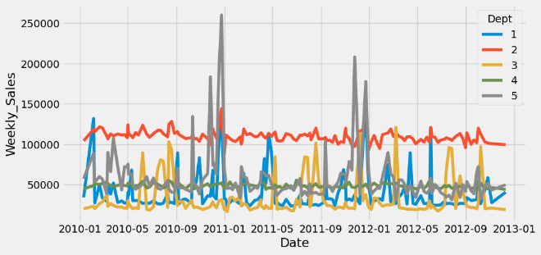

From the trend, we can observe that:

a) Dept 1: Sales exhibit a notable increase in April, with another peak observed towards the end of the year in November and December.

b) Dept 2: Sales show a steady ascent until September, followed by a significant surge in December.

c) Dept 3: Sales remain stable, with substantial increases noted in August and September, along with a minor uptick in December and January. This department likely caters to educational and stationery products.

d) Dept 4: Sales within this department have maintained a consistent trajectory over the years, experiencing minor fluctuations.

e) Dept 5: Sales for this product demonstrate a spike in the early months of the year, followed by a substantial increase in December

**Marketing Campaign**

Now, to perform Causal Inference Analysis, let's go ahead and create a situation where we induce some changes in the dataset and analyze it using the methodology.

As the sales for Dept 4 is pretty consistent, we can induce some changes like a rise in sales due to the Marketing Campaign for Q3-2012 i.e. months of July to September.

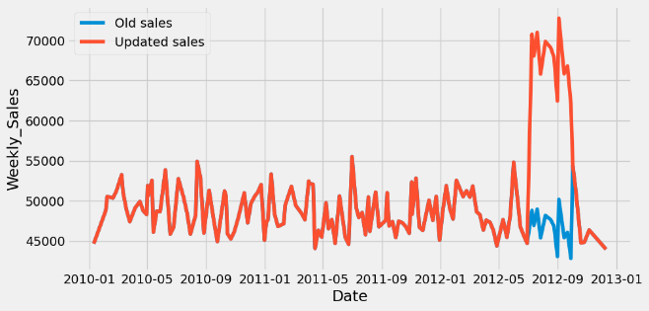

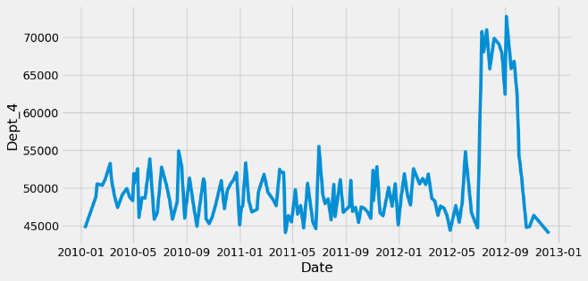

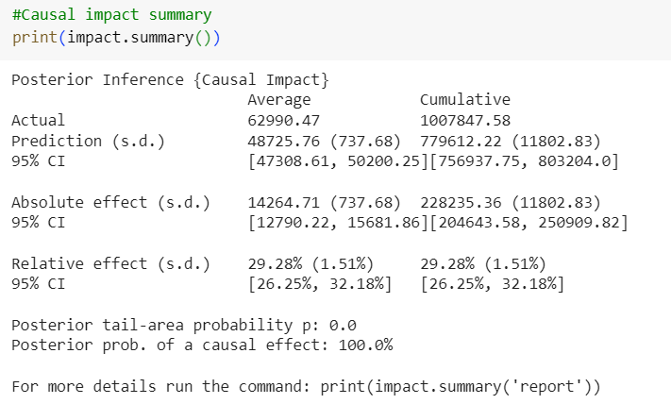

As per the summary, the predicted relative effect is around 30% whereas the lift we induced in the dataset was 45% . The 95% CI for it is 26% to 32%. This is a satisfactory result with a p value close to zero.

**Analysis report {CausalImpact}**

During the post-intervention period, the response variable had

an average value of approx. 62990.47. By contrast, in the absence of an

intervention, we would have expected an average response of 48725.76.

The 95% interval of this counterfactual prediction is [47308.61, 50200.25].

Subtracting this prediction from the observed response yields

an estimate of the causal effect the intervention had on the

response variable. This effect is 14264.71 with a 95% interval of

[12790.22, 15681.86]. For a discussion of the significance of this effect,

see below.

Summing up the individual data points during the post-intervention

period (which can only sometimes be meaningfully interpreted), the

response variable had an overall value of 1007847.58.

By contrast, had the intervention not taken place, we would have expected

a sum of 779612.22. The 95% interval of this prediction is [756937.75, 803204.0].

The above results are given in terms of absolute numbers. In relative

terms, the response variable showed an increase of +29.28%. The 95%

The interval of this percentage is [26.25%, 32.18%].

This means that the positive effect observed during the intervention

period is statistically significant and unlikely to be due to random

fluctuations. It should be noted, however, that the question of whether

this increase also bears substantive significance can only be answered

by comparing the absolute effect (14264.71) to the original goal

of the underlying intervention.

The probability of obtaining this effect by chance is very small

(Bayesian one-sided tail-area probability p = 0.0).

This means the causal effect can be considered statistically significant.

**Inventory Management**

**Seasonal Forecasting:** Utilize temperature data to forecast seasonal demand fluctuations. Allocate inventory space and resources accordingly to meet the anticipated demand for seasonal products.

**Dynamic Pricing:**

Incorporate CPI data to adjust pricing strategies in response to changes in consumer purchasing power. Offer promotions or discounts during periods of low inflation to stimulate sales.

**Supply Chain Optimization:**

Monitor fuel price fluctuations to anticipate changes in transportation costs. Optimize supply chain routes and distribution networks to minimize the impact of fuel price changes on logistics expenses.

**Marketing Strategies**

**Targeted Campaigns:**

Tailor marketing campaigns based on regional climate conditions to promote relevant products. For example, launch winter clothing promotions in colder regions and summer gear promotions in warmer areas.

**Price Sensitivity Analysis:**

Analyze consumer response to price changes using CPI data. Adjust pricing strategies to maximize revenue while remaining competitive in the market.

**Promotional Timing:**

Coordinate marketing efforts with fluctuations in fuel prices. Launch promotions or special offers during periods of low fuel prices to offset potential decreases in consumer discretionary spending.

**Store Optimization**

Product Placement: Arrange store layouts to reflect seasonal demand patterns identified through temperature data. Highlight relevant products prominently to attract customer attention.

**Inventory Turnover:**

Use CPI data to optimize inventory levels and minimize carrying costs. Adjust stock levels based on changes in consumer spending patterns to ensure optimal turnover rates.

**Customer Experience:** Leverage insights from fuel price data to offer convenience-oriented services, such as online ordering with flexible delivery options, to mitigate the impact of increased transportation costs on consumers.

**Challenges in implementing these strategies may include**

**Data Integration:**

Ensuring seamless integration of diverse data sources (temperature, CPI, fuel prices) into existing systems for accurate forecasting and decision-making. Resource Allocation: Allocating resources effectively to implement dynamic pricing strategies and targeted marketing campaigns based on real-time data analysis.

**Operational Flexibility:** Adapting supply chain and inventory management processes to respond quickly to changes in external factors, such as sudden fluctuations in fuel prices or unexpected shifts in consumer behavior.

**Competitive Pressures:** Navigating competitive pressures and market dynamics while adjusting pricing strategies to maintain profitability and market share. Addressing these challenges requires a combination of technological capabilities, strategic planning, and organizational agility to leverage the insights gained from external factors effectively.

**Conclusion:**

In conclusion, this project aimed to develop robust forecasting models for weekly sales at both store and department levels while incorporating various external factors such as the Consumer Price Index (CPI), unemployment rate, fuel prices, and store/department attributes. By exploring short-term forecasting using SARIMA and long-term forecasting using Random Forest, we sought to understand how these models could predict sales under different time horizons.

Furthermore, we investigated how external factors, including economic indicators and regional climate, influence sales patterns. By incorporating these insights into our demand forecasting models, we aimed to enhance the accuracy and reliability of our sales predictions.

One of the key findings from our analysis was the significant impact of interventions on sales performance, as evidenced by the CausalImpact analysis. The intervention led to a statistically significant increase in sales, indicating the effectiveness of the strategies implemented.

Based on the insights gathered, we formulated a comprehensive strategy for inventory management, marketing, and store optimization. This strategy leverages the forecasting models to anticipate demand, optimize inventory levels, and tailor marketing efforts to specific customer segments and market conditions.

However, implementing these strategies may present real-world challenges, such as data availability, model complexity, and operational constraints. Addressing these challenges will require collaboration across departments, investment in data infrastructure, and ongoing monitoring and refinement of the forecasting models.

Overall, this project provides valuable insights into the factors influencing sales and offers actionable recommendations for businesses to improve their forecasting accuracy and strategic decision-making. By leveraging advanced analytics techniques and incorporating external factors into demand forecasting models, businesses can better adapt to changing market conditions and drive sustainable growth.